FORBES SPORTSMONEY
Feb 27, 2022, 06:00am EST

Golf Saw Record Play Totals Last Year, On Heels Of Covid-Fueled 2020 Boom
Erik Matuszewski
Contributor

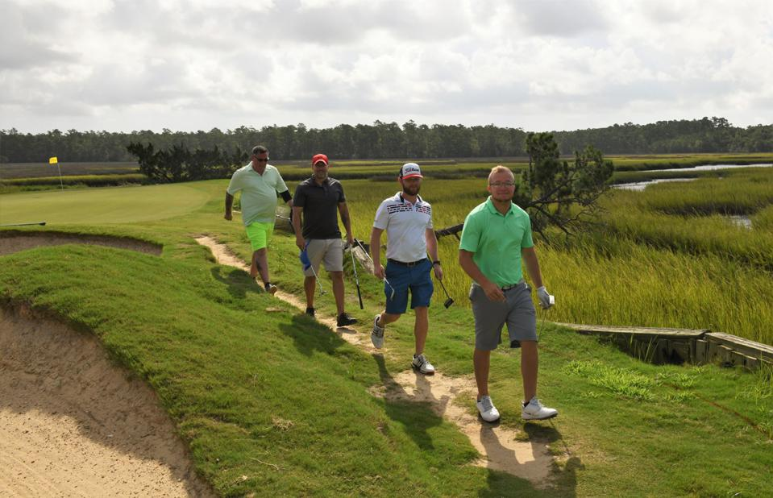
Competitors at the 2021 World Am in Myrtle Beach, South Carolina. Rounds of golf in Myrtle Beach saw a significant year-over-year jump in 2021. GOLF TOURISM SOLUTIONS
If it seemed like tee times were harder to come by last year, it wasn’t your imagination. There were more rounds of golf played at courses across the U.S. than at any time in history. Ever.
This after a record-setting, Covid-driven boom during the second half of 2020.
What’s interesting is that as golf engagement remains strong, the rationale for why golfers have increased their play has seen a shift. During late summer of 2020, before vaccines were rolled out and people were seeking safe, social activities they could pursue, 67% of golfers credited their increased play to “having fewer alternative ways to spend leisure time,” according to a National Golf Foundation consumer survey. When the NGF revisited the same question in late 2021, the feedback was different, with 56% of respondents saying golf became “more of a priority.”
This is more good news for golf operators, who saw play increase by almost 6% nationwide in 2021. When you’re talking about one of the country’s most popular participation sports – an $84 billion-plus industry — that rise equates an extra 30 million rounds alone. And last year’s biggest increases in play were seen at public-access golf facilities, from the local municipally-run course to resort and destination courses that were typically more operationally hamstrung than others as golf thrived in 2020. When 2020 was in the books (and those tee sheets were busy through the end of the year), play finished up an unprecedented 20% at private clubs and 12% at muni, resort and daily fee public courses.
In 2021, overall play remained about the same at private courses while rounds at public facilities jumped almost another 7%.
“Avid golfers were playing more golf, less than avid were playing more golf, and beginners were going out for the first time,” said Bill Golden, CEO of Golf Tourism Solutions, a marketing cooperative that promotes golf-related tourism in golf-rich Myrtle Beach, South Carolina. “So there was a resurgence there, which benefits everybody, not just the local golf courses in their hometown. It also picks up demand for travel.”
Given that travel and tourism were slower to recover in the golf business in 2020, Myrtle Beach is a highly-visible example of a region that enjoyed a big boost in 2021. It was almost a record-setting year in terms of rounds and revenue, as play rose 19% last year, with more than 2.3 million rounds played at the 62 courses tracked by Golf Tourism Solutions.

Participants in the World Am in Myrtle Beach, an area that saw a 19% increase in 2021 play.
On the municipal golf side, the trajectory was also particularly strong in areas that had been more affected by early virus-related restrictions.
Take the city of Chicago, which had some of the longest golf-related shutdowns in the nation in 2020, with five facilities closed for 2 ½ months and another for a full three months. As a result, the Chicago Parks District last year saw play jump by 27% at its six courses.
“I attribute the success in 2021 directly to our pandemic response in 2020,” said Bill Colgan, Regional Director of Operations for Indigo Golf Partners, which operates the Chicago Parks District courses. “Honestly, I think our 2020 story was more noteworthy than 2021. Golf was a safe activity all along, but we had to prove it to elected officials.”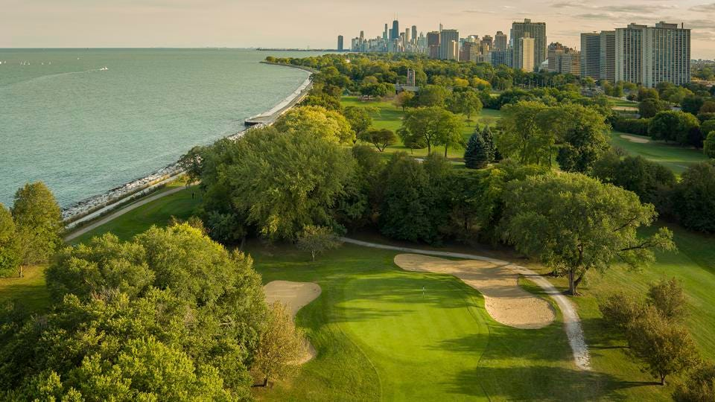
An aerial of the Chicago skyline and the Sydney Marovitz municipal golf course, one of six Chicago Parks District golf facilities that saw a significant jump in play during 2021
PETER WONG
As the 2022 golf season gets underway, there’s no question golf has benefited from its standing as a safe, outdoor sport — for participants young and old, for friends and families, for the dedicated diehards and for those picking up or getting back into the game. It’s a physical, mental and social escape that golfers have been embracing with greater frequency than even when Tiger Woods was in his prime and there were more golfers and golf courses throughout the U.S.
And, with more demands (and distractions) on our time than ever, it’s particularly encouraging to see indications that more golfers are making golf more of a priority. The question, of course, is whether it will stay that way.
Follow me on Twitter.
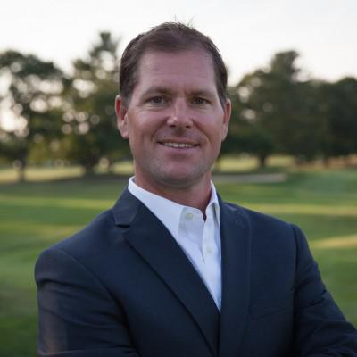
Erik Matuszewski

I’ve spent more than two decades in journalism, writing about sports and its prominent intersection with the business world while covering just about every major sporting event: Super Bowls, the World Series, the NBA and NHL Finals, the Olympics and golf’s major championships. I’ve played video games with NFL stars, golf in the shadow of the Great Wall in China and dug into the batter’s box at Yankee Stadium. My passion is golf, which has led me to drive 20 straight hours to make a tee time in Florida, crisscross the country to play two U.S. Open venues in consecutive days on opposite coasts, and travel to China to play Pine Valley since I’ve never teed it up at the celebrated one in New Jersey, despite spending my entire life in the state. I'm fortunate enough to be immersed in golf as editorial director for the National Golf Foundation, the industry's leading provider of research (all the data that helps businesses in golf succeed). I still live in the Northeast, where I’m doing my part to grow the game of golf with my three kids, and am always looking to find someone in the world of sports with a compelling story or positive message. Know a person or company like that? I’d love to hear about it. Let me know by dropping me an email (ematuszewski24@gmail.com) or reach me on Twitter at @ematuszewski.

